Runecraft Documentation

The complete documentation for Runecraft, a Minecraft Mod

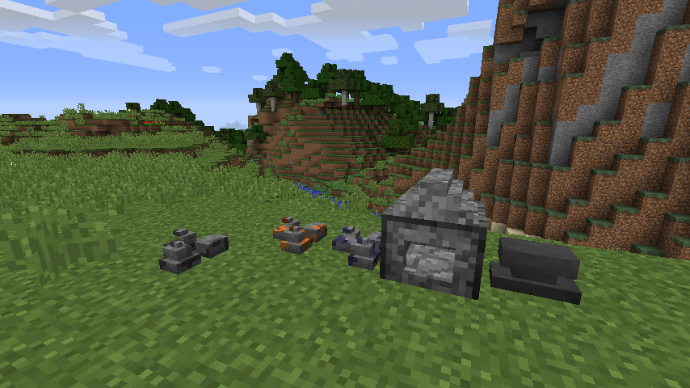

Kees Nijenhuis

Table of Contents

About Runecraft 3

Leveling System 4

The Skill Checker 4

# About Runecraft

Runecraft is a Minecraft mod made using Minecraft Forge. The goal of this mod is to recreate the game made by Jagex, Runescape. The mod is aiming to recreate the feeling and atmosphere of the old school Runescape game, also known as Runescape 2007.

If you have ever played Runescape you will most likely know that Runescape and Minecraft are two entirely different games, Runescape is a click and move game, whereas Minecraft is a game where you use the WASD keys to move the player. Minecraft is practically an infinite open-world sandbox game, and Runescape is a manmade map that, in comparison to a Minecraft world, is really small.

So how do we go about recreating Runescape in Minecraft? Simple, firstly we remove any Vanilla Minecraft blocks, items, recipes, world generation that is not needed in a Runecraft world. Secondly we add some items and blocks that are also present in Runescape think of ores, weapons and armor. From there we add a leveling system, custom furnaces that work the same way, or almost the same way, as the Runescape furnace. If we do this for every skill we eventually get an almost complete Runescape feeling in Minecraft.

# Leveling System

In Runescape there is the same leveling system as in Runescape. For smelting experience you use a furnace to refine ores into bars. For cooking you do almost the exact same thing, but you replace the ores for raw food and the furnace for something less hot.

## The Skill Checker

The Skill Checker is an item which is used to look at your current stats. Because of the lack of space in Minecraft we decided to not have an overlay with your stats on the same screen as your hotbar, instead we went for an item which on right click opens a Graphic User Interface with all your current stats.

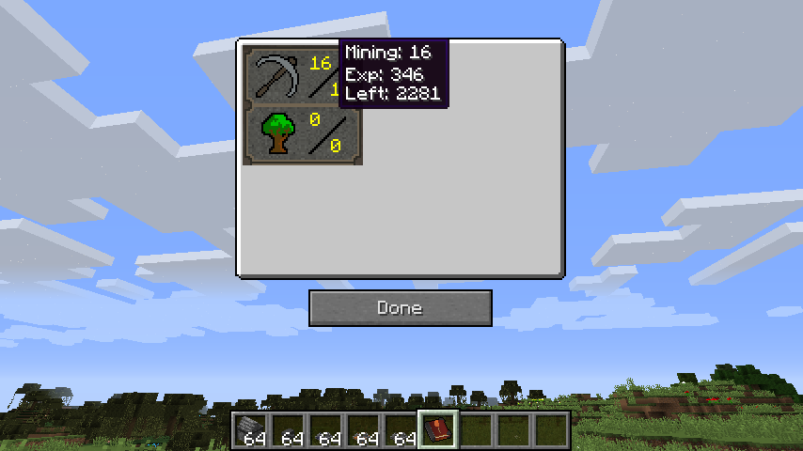As you can see here in this early version of development there are only two skills added here, Mining and Woodcutting. If you hover the cursor over a skill it will show you the current level of the skill, how much experience points you currently have in this level and how much experience points you need to advance a level.

There is one more thing to this GUI. If you move your cursor over a skill and press left mouse button a new screen will appear, this is the same screen as in Runescape when you click on a skill. The new screen will show information about at what level you can use a certain tool, chop down a certain tool, et cetera.

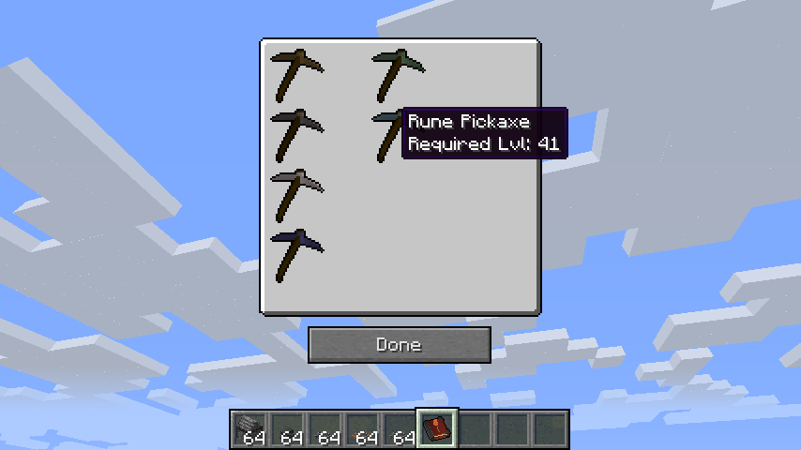If you move your cursor over a tool in the Mining screen you can see the name and the level required to use the pickaxe.